|  |
| --- |
| , RD Dep. |
| **Introduction to OLAP** |

|  |  |  |  |  |  |
| --- | --- | --- | --- | --- | --- |
| REVISION HISTORY | | | | | |
| Ver. | Description of Change | Author | Date | Approved | |
| Name | Effective Date |
| 1.0 | Initial Version | Aliaksei Belablotski | 12-Feb-2012 |  |  |
|  |  |  |  |  |  |

Contents

1. Install Oracle SQL Developer 3

1.1. Download Oracle SQL Developer 3

1.2. Establish Connection with Database Server 3

2. Explore Sales History Schema with Oracle SQL Developer Data Modeler 3

2.1. Create Model of Sales History Schema 3

3. Explore Sales History Data with Oracle SQL Developer Reports 3

3.1. Analytical Reports 4

4. Tasks Results 4

4.1. Data Model 4

4.2. Reports 4

# Install Oracle SQL Developer

## Download Oracle SQL Developer

Download the latest version of Oracle SQL Developer from <http://www.oracle.com/technetwork/developer-tools/sql-developer/overview/index.html>

The easiest way is to get binary named “[Oracle SQL Developer for 32-bit Windows](http://www.oracle.com/technetwork/developer-tools/sql-developer/downloads/index.html) (This zip file includes the JDK1.6.0_11)”.

## Establish Connection with Database Server

Select connection type “**Basic**”, role “**Default**”

Database Server: **EVBYMINSD1218**

Port: **1521**

Service name: **ORCL1218.minsk.epam.com**

Use appropriate User name and Password to log on this server.

# Explore Sales History Schema with Oracle SQL Developer Data Modeler

## Create Model of Sales History Schema

Import Sales History Metadata into Data Modeler. Explore Sales History Schema’s tables and relationships.

Find out fact and dimension tables into Sales History; create sub-views for all stars into this schema.

# Explore Sales History Data with Oracle SQL Developer Reports

Create report “Company Sales by Channel and Year” which contains data for United States of America, Germany, United Kingdom, Netherlands, Ireland, Denmark and France.

Consider to use Table, Chart and Gauge views. Store your reports in “User Defined Reports” folder into SQL Developer.

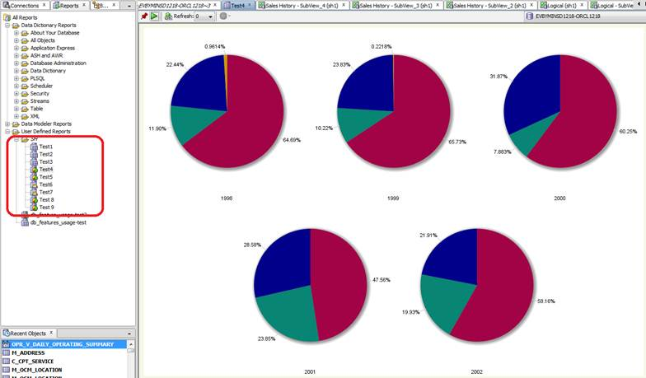

## Analytical Reports

Formulate three the most valuable business questions (from your point of view) which could be resolved with information from Sales History. Create user-defined report for each of these questions.

# Tasks Results

Please do tasks above. Next prepare all artifacts listed below, pack all files into zip-archive (name this archive with your EPAM login: name_surname.zip). Send it to [Aliaksei_Belablotski@epam.com](mailto:Aliaksei_Belablotski@epam.com)

## Data Model

* Save stars sub-views into PNG images.
* Export entire data model.
* Briefly describe Sales History schema (what information is stored into it). Provide description for each table in Sales History. Compose Microsoft Word document, template is below.

|  |  |  |
| --- | --- | --- |
| Sales History schema is used for…  With that data we can…  … | | |
| Table Name | Table is used for | Additional Notes |
| … | … | … |

## Reports

* Compose text document (Microsoft Word) which describes goals of your reports.
* Generate PDF output for your reports (name they report0.pdf, report1.pdf, report2.pdf, report3.pdf).
* Export your reports (name they report0.xml, report1. xml, report2. xml, report3. xml).